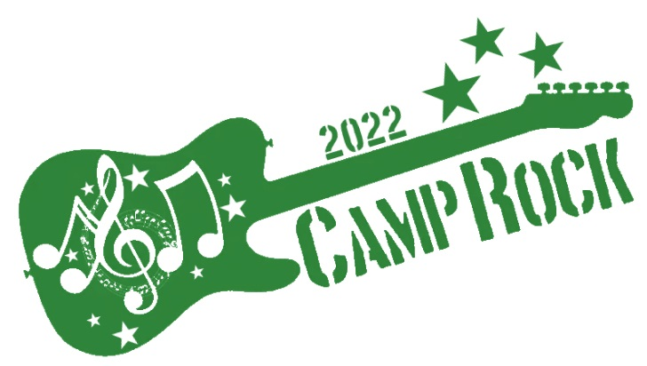
19th November 2022

THIS YEAR’S THEME IS
Oak Lodge at Thriftwood provides a large space which we will transform according to our chosen theatrical theme.
It is a space where we can hold high energy, fun filled ‘music and movement’ activities. We have full access to a lighting and sound desk for the opportunity to invite acts to perform and entertain our members.
THIS YEAR WE HAVE:-
- West End Singer show case
- Talent Show
- Music Therapy
- UV Disco
- Three Course Meal

Camp Rock is designed to give all members a musical theatre therapy experience that they will never forget.

Based in a fully adapted setting with disabled toilets, great to facilitate our members, it is going to be an event of lights, camera, ACTION!

We have access to the wonderful outdoor area too, which is just breath taking and literally at our back door!

Let the good times roll!

As always, if any member is unable to access this event independently, I ask that they are accompanied by their carer, thank you.

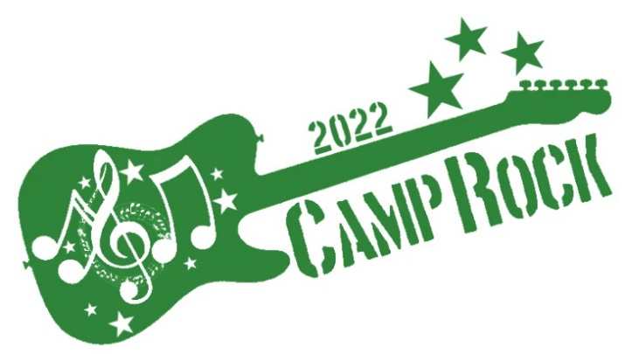

REGISTRATION INFORMATION FORM

Saturday 19th November - £47.50 – 3pm - 9pm
Camp Member:
Camp Member DOB:
Emergency contact name:
Relationship to Camp Member:
Emergency contact number:
Emergency contact address:
Email address:
Carer’s name:
For any adult that is unable to access this event independently a carer must attend
Carer’s contact number:
T shirt size required:
S |  | M |  | L |  | XL |  | XXL
Please tick which size you require (one only)
Additional information:
Please include anything we should know, such as allergies, likes, dislikes etc
Payment via Bank transfer or Cheque
Account number: | 10194330
Sort code : | 16 – 12 - 33
Cheques made payable to: | AK EVENT MANAGEMENT
Please return form along with payment to Leah or by email theaceco@hotmail.com or 07934 442 854
To avoid disappointment please make your booking before 5th Sept 2022

